**Project Description:**

**Wireless Parking Sensor System**

**Group 2**

Lim Zhi En

Tang Wei Qi

Michael Mugo

Mohammad Syamil

**Aim**

* To develop a wireless parking sensor system for the University of Nottingham Malaysia Campus.

**Objectives**

* Create an Android application that displays the layout and real-time occupancy of the parking bays in campus.
* Utilize the Android phone camera as a sensor to detect the presence of a vehicle.
* Create a server with an online database to store and update information.
* Create a car park counter to display the availability of parking bays in each zone.

**Background and Motivation**

Due to the rapidly increasing number of vehicles being used every day and the lack of carpooling practices, the students and staffs in UNMC always face difficulty in finding free parking bays nowadays, especially during the peak hours. We also found that the recent changes being introduced to the university traffic policy, which aim to reduce the carbon footprint of the campus, do not solve the aforementioned problem. In fact, the latest policy actually narrows down the parking choices the students used to have, causing them to waste more valuable time and petrol in searching for empty parking slots. Without a proper parking guide system, they tend to drive all around the campus without any leads while hoping to spot an empty parking space. It is also very likely that the students or staffs often miss the opportunity to secure a car park space as some car park spaces may become available immediately after them passing by. As a result, most of them will end up parking at parking zones very far away from their destination. This has become one of the major reasons of the students turning up late for classes.

**Project Plan**

Basically this wireless parking sensor system will consist of a server with an online database, a user Android application, a car park counter and the native camera of an Android phone, being utilized as a vehicle sensor. The phone camera will detect whether there is a car parked at a particular parking bay and send a signal to the online database. The database will automatically update the availability of the parking bays in each car park zone. Once the users switch on the Android application on their phones, it will fetch the data of the parking space availability from the database and display it on the map layout so that the users can check on the location of the available parking bays at that moment.

User Phone

(Application)

Recycled phone

(Sensor)

Database

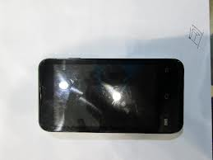  

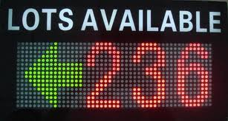

Car Park Counter

Display

*Figure 1: System Model*

**Android application**

The user application will show the UNMC car park layout where the users can see the availability of parking spaces. When there is one, it shall be highlighted on the map interface. Besides, this application will have the ability to search for the nearest parking bays in relation to user’s destination, also enabling the users to manually mark the locations where their cars are parked at.

**Car park counter display**

As for the parking zone counters, these shall be placed at each parking zone. Each counter will display the number of parking bays available at the particular zone. These counters will retrieve the availability of car park spaces from the database and display it to the users as they drive around the car park zone.

**Vehicle sensor**

The sensor shall be developed in the form of an Android application that will access and fully utilize the camera of the recycled Android phone. The camera will capture pictures within a given time interval which shall then be sent to the server. The server will process the image to detect whether the parking bay is occupied or not.